**Assignment 03**

**ITC**

Name: Taaha Hussain Khan

Roll No: L1F21BSCS0917

Section: A21

Topic: Nested Loop

(Question 01)

#include<iostream>

using namespace std;

int main()

{

for (int i = 1; i <= 5; i++)

{

for (int j = 1; j <= i; j++)

{

cout << " " <<(i*j);

}

cout << endl;

}

system("pause");

return 0;

}

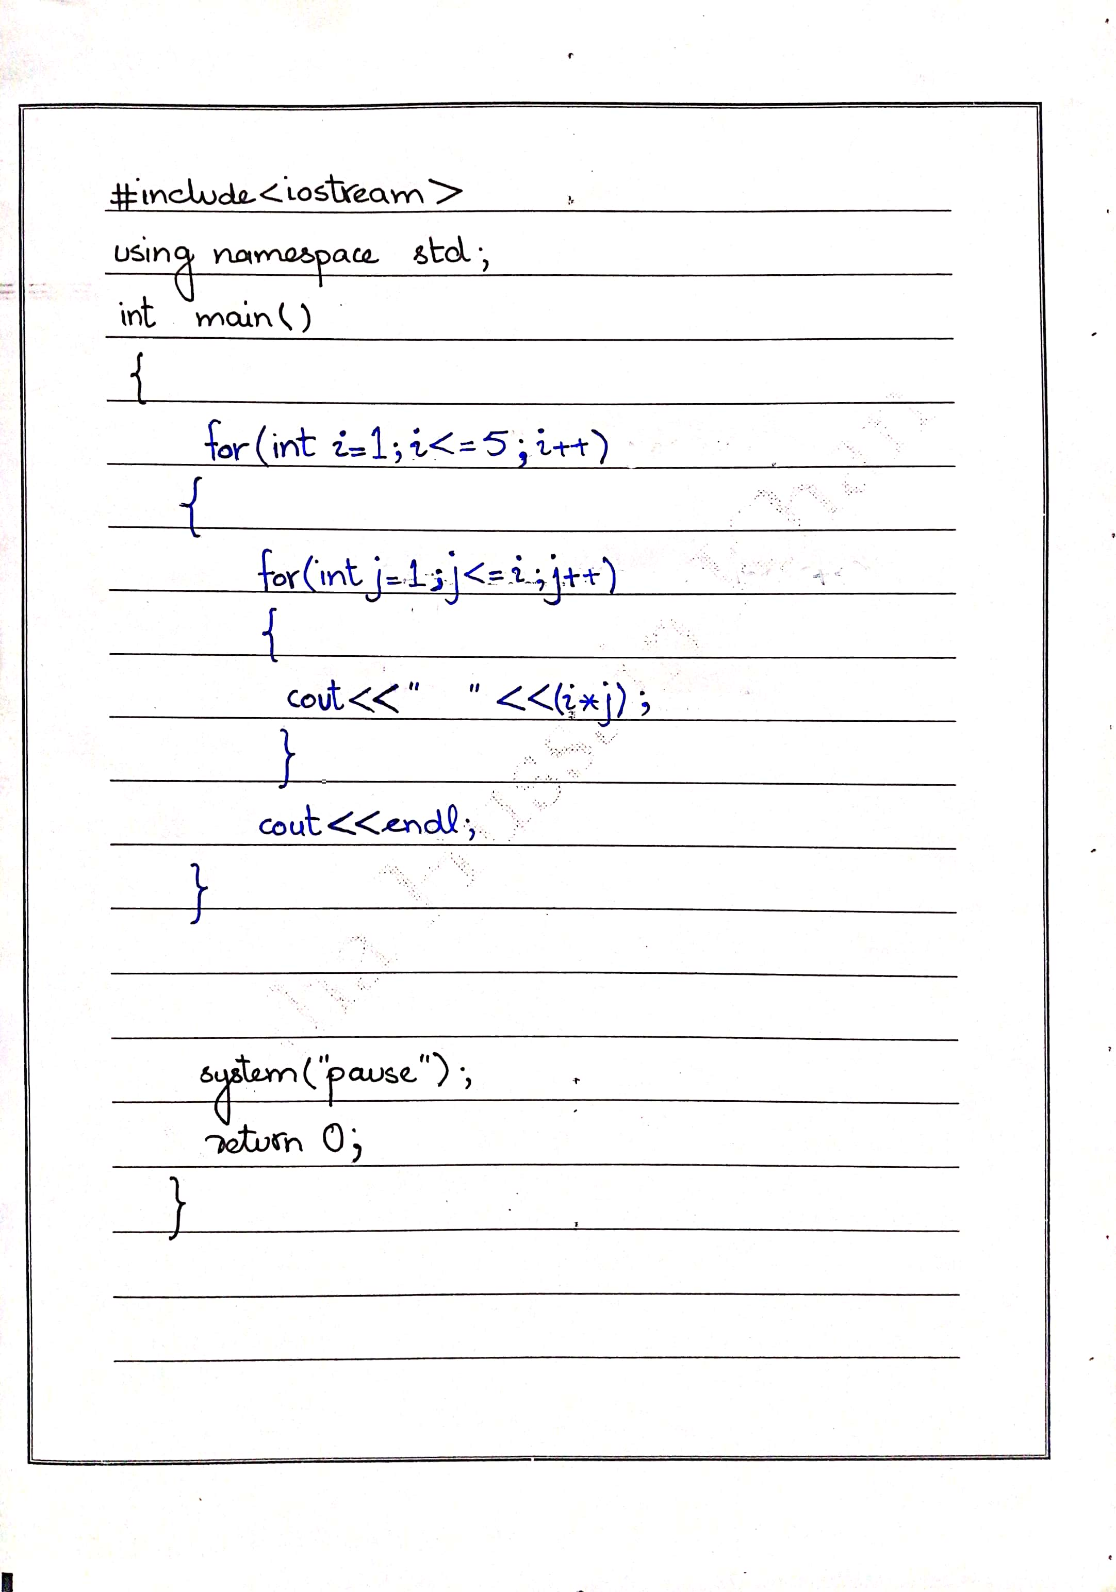

Output:

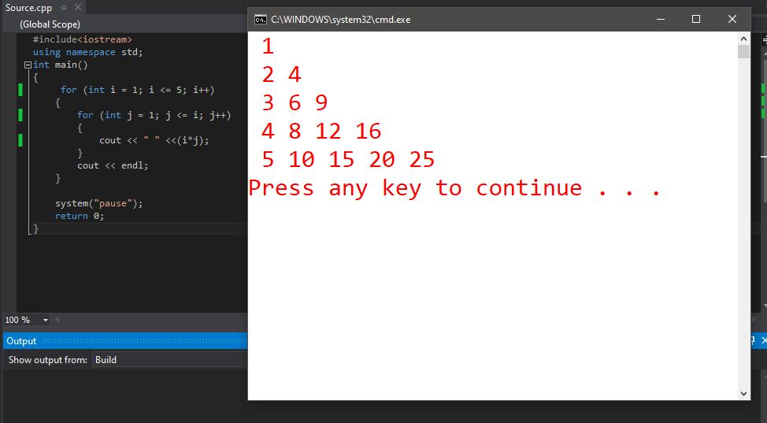

(Question 02)

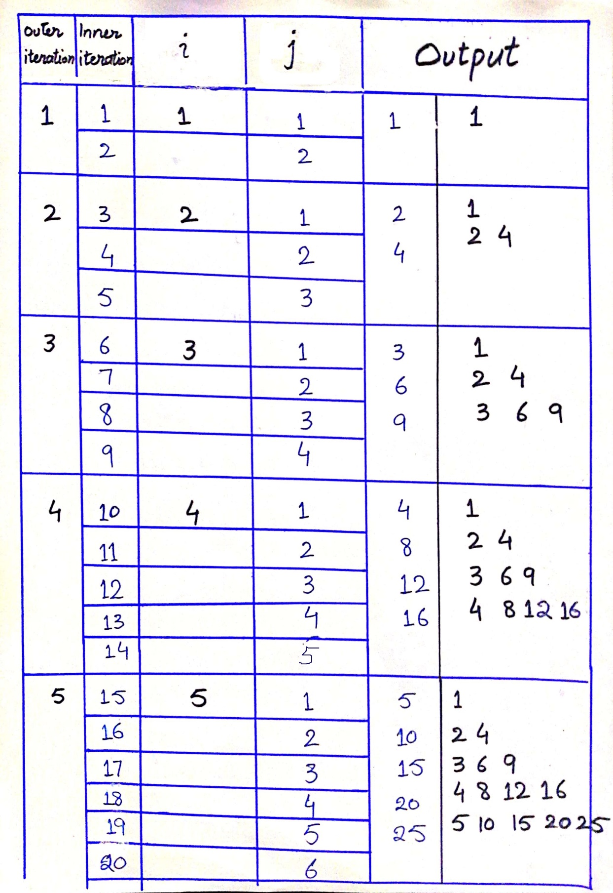

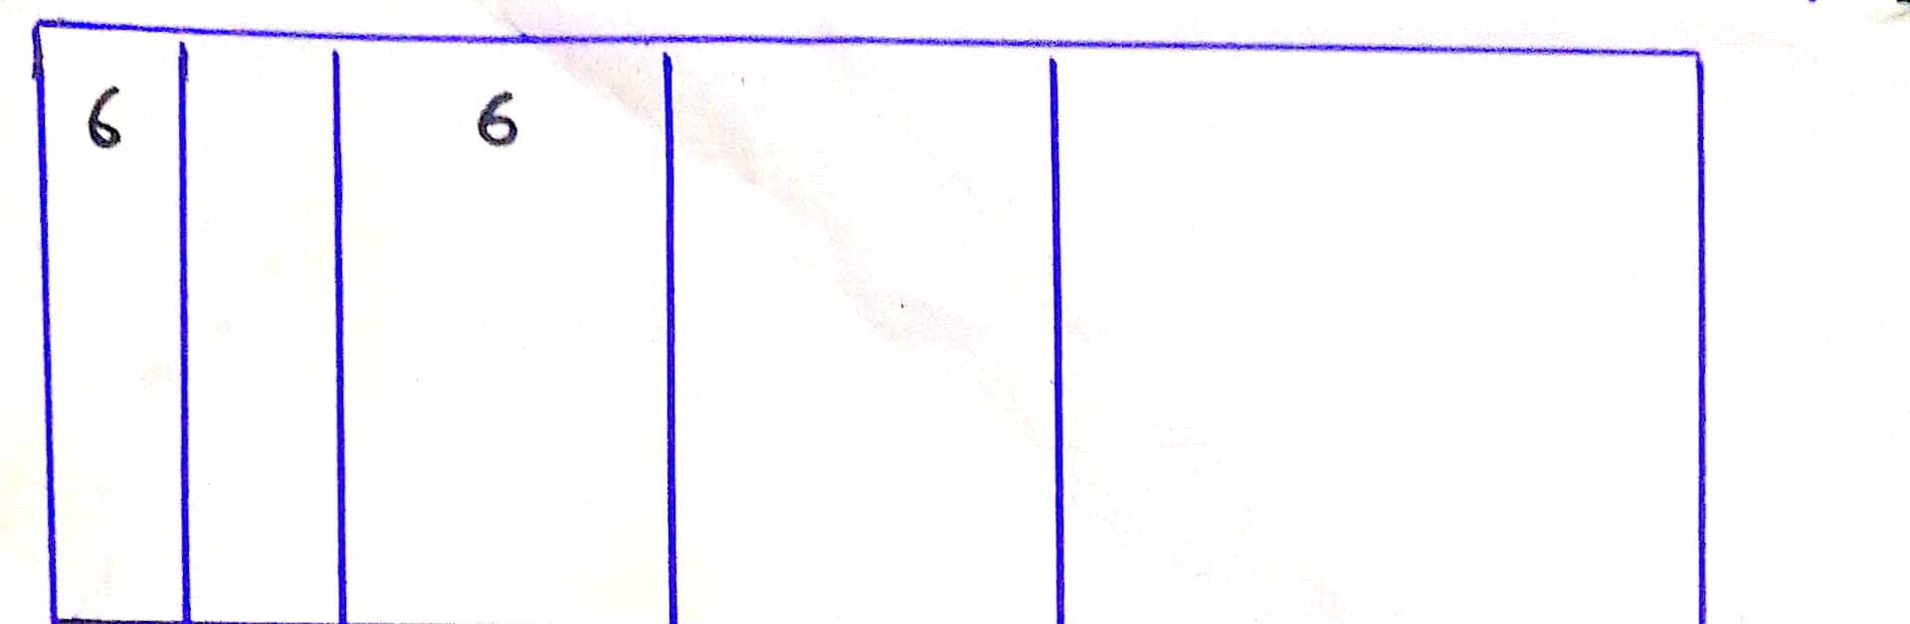

|  |  |  |  |  |  |
| --- | --- | --- | --- | --- | --- |
| Outer Iteration | Inner Iteration | i | j | Output | |
| **1** | **1** | **1** | **1** | **1** | **1** |
|  | **2** |  | **2** |
| **2** | **3** | **2** | **1** | **2** | **1**  **2 4** |
|  | **4** |  | **2** | **4** |
|  | **5** |  | **3** |  |  |
| **3** | **6** | **3** | **1** | **3** | **1**  **2 4**  **3 6 9** |
|  | **7** |  | **2** | **6** |
|  | **8** |  | **3** | **9** |
|  | **9** |  | **4** |  |  |
| **4** | **10** | **4** | **1** | **4** | **1**  **2 4**  **3 6 9**  **4 8 12 16** |
|  | **11** |  | **2** | **8** |
|  | **12** |  | **3** | **12** |
|  | **13** |  | **4** | **16** |
|  | **14** |  | **5** |  |
| **5** | **15** | **5** | **1** | **5** | **1**  **2 4**  **3 6 9**  **4 8 12 16**  **5 10 15 20 25** |
|  | **16** |  | **2** | **10** |
|  | **17** |  | **3** | **15** |
|  | **18** |  | **4** | **20** |
|  | **19** |  | **5** | **25** |
|  | **20** |  | **6** |  |  |
| **6** |  | **6** |  |  |  |